Mucha Assignment 6

Proposal Outline: DUE March 27th at Midnight
(LastName_Assignment6.doc on D2L)

1) Revise Title

Pitted Terrains on Mars: Modeling High Priority Targets in the Search for Life

2) Revise abstract.
Adhere to word limit: The abstract must be written in standard ASCII and should be no longer than 20 lines of 85 characters of text. Use the HST/JWST Templates.

​​Recent high-resolution images of the Martian surface collected by the High Resolution Imaging Science Experiment (HiRISE) have captured enigmatic pitted structures within impact craters, interpreted to be the remnants of post-impact hydrothermal systems. These hydrothermal systems are theorized to be transiently habitable systems on the surface of Mars, an otherwise cold and nutrient-depleted planet, indicating pitted structures may be unique high-priority targets in the search for extinct and extant life. However, the dynamics of hydrothermal circulation is uncertain owing to the complexity of fluid flow and heat dissipation within vent pipe structures, making it challenging to define habitable regions on Mars. We propose a novel approach to model steam escape vent pipe formation, using the finite element modeling software COMSOL Multiphysics. The advanced capabilities in modeling heat transfer and fluid flow offered by COMSOL Multiphysics have not been applied to the study of Martian impact crater hydrothermal systems. The proposed models will thus improve our understanding of these structures and validate their status as primary targets in the search for habitable terrains. The results of this proposed program will be critical to ongoing research on the Martian surface, including informing future sampling missions and selecting optimal targets for astrobiological exploration.

Science Justification will need to be 3 pages in total. This includes 1 figure, but not the bibliography.

Science Justification Outline

3) Provide an outline for your proposal (BULLETED POINTS that answer each of the below)

Section 1: Facts, Problem & Summary paragraph (3/4 of a page)

a) What is the descriptive heading? It must be a statement

Modeling Pitted Terrains Will Permit a Habitability Assessment of Mars

b) 1 fact-based paragraph:
i) State the fact leading the paragraph (the conclusion) – this should follow from the abstract.

- HiRISE has captured enigmatic pitted structures on the floors of Martian impact crater Tooting,
interpreted to be the remnants of an impact-generated hydrothermal system

ii) What would be supporting facts (1-3)? Provide at least one paper citation per supporting fact.

- Pitted terrains are theorized to form from the escape of volatiles, which entrain and deposit
material on the surface in pits (Boyce et al., 2012)
- Pitted terrains can be used as a proxy for crustal volatile content on a large scale (Tornabene
et al., 2012)
- Impact generated hydrothermal systems, proposed as promising targets in the search for life,
can form following impact processing (Rathbun and Squyres, 2002)

iii) What is the nuanced conclusion for the paragraph? This is the importance of the fact
that should set the stage for the problem (should follow from abstract)

- From abstract: These hydrothermal systems are theorized to be transiently habitable systems on the surface of Mars, an otherwise cold and nutrient-depleted planet, indicating pitted structures may be unique high-priority targets in the search for extinct and extant life

c) Problem paragraph:

iv) What is “the problem” statement?

- Defining habitable regions within impact structures on Mars is challenging owing to the
unknown dynamics of fluid flow and heat dissipation within steam escape vent pipe structures.

v) What references are needed to support the problem?

(DeBlasio, Caccia, and Crosta, 2025)
(Boyce et al., 2012)
(Rathbun and Squyres, 2002)
(Tornabene et al., 2012)

vi) Why is the problem critical to answer now? (nuanced conclusion)

- HiRISE imaging allows for detailed topographic analyses
- NASA priorities include assessing habitability of Mars terrains, this modeling program will
address these themes and offer insights into the selection of astrobiology targets for future
study

d) Synopsis paragraph:

vii) What is the proposal? (identify key component) “We propose”

- We propose a modeling program to investigate the formation of steam escape vent pipe
structures within Tooting Crater

viii) Why the facility? This can be related to the funding call.

- COMSOL Multiphysics will be used in the modeling program, due to its advanced capabilities
in heat and fluid flow

ix) What is the broader impact ? Community deliverables?

- Broader impact: deeper understanding of volatile content within the Martian crust in Amazonis
Planitia, and insights into habitability of impact generated hydrothermal systems
- Community deliverables: modeling framework (COMSOL Multiphysics) which can be applied
to other hydrothermal structures/impact craters on Mars

Section 2: The Problem & Motivation/Narrative of the proposal

a) Identify a descriptive heading that states the problem

Unconstrained Steam Escape Dynamics Inhibit Habitability Assessments

b) What fact do you need to start with to set up the problem?

- pitted structures form from the ejection of subsurface material during the volatile degassing
processes following an impact event (description of how these structures form, and how they
are connected to volatiles/water)

c) What references support the problem?

(DeBlasio, Caccia, and Crosta, 2025)
(Boyce et al., 2012)
(Rathbun and Squyres, 2002)
(Tornabene et al., 2012)

d) State why solving this problem advances the subfield.

- Addressing this problem will allow for estimates of the habitable timescales of
impact-generated hydrothermal systems, which provides limitations on potential for microbial
colonization

e) Identify the “key component” missing to solve the problem.

- A deeper understanding (volatile escape speed, duration of volatile degassing, and crustal
volatile content) of the dynamics of pitted terrain formation within impact craters

f) State that this program will generate the “key component” to solve the problem.

- Modeling with COMSOL Multiphysics will provide constraints on the dynamics of pitted terrain
formation (volatile escape speed, duration of volatile degassing, and crustal volatile content)

Section 3: The Strategy: HST/JWST + Target Solves the Problem (Generate the “Key Component”)

a) Create a descriptive heading that states the strategy → “This Proposal: Observe/Model This Thing”

This Proposal: Modeling Vent Pipe Structures Within Tooting Crater

b) What are you targeting ? (imaging/spectra/archival data of what astronomical object, or what physical mechanism/simulations/data set)

- target is a simulation (model) of steam escape through impact melt/breccia within Tooting
Crater, forming vent pipe structures

c) Why this facility? (Why HST/JWST?)

- COMSOL Multiphysics will be used in the modeling program, due to its advanced capabilities
in heat and fluid flow
- COMSOL has never been applied to this problem, which means the approach is entirely novel
- only COMSOL has advanced enough capabilities to address this problem

d) Outline (bullets) the strategy to generate the key component
- For GO: describe the proposed observations *briefly/succinctly*
- For AR/Theory: describe *briefly* the analysis method/proposed usage of simulations/codes and relation to existing/future HST/JWST data sets.
- You must explain how the figure will be used to support the strategy

- Reconstruct a flared, symmetrical vent pipe structure (conduit) within 3D space in COMSOL
Multiphysics
- Utilize the heat transfer in porous media, heat transfer in solids and fluids, and conjugate heat
transfer modules to construct the steam escape system
- Figure illustrates general model geometry and highlights terrains targeted by this proposal

e) Outline the products of the program (tangible outcomes)

- Constrain speed of steam escape required to produce observed surface features through
particle entrainment and transport
- Calculate pre-impact crustal volatile content required to produce observed surface features
- Constrain duration of elevated temperatures in the post-impact hydrothermal system

f) How do these products solve the problem?

- These constraints (escape speed, crustal volatile content, and system duration) will permit
evaluation of the habitability of impact generated hydrothermal systems

Include a Figure that explains the strategy/target/solution
Add here your (revised) Figure from Assignment 4 (or you must create a new one if your proposal is different)

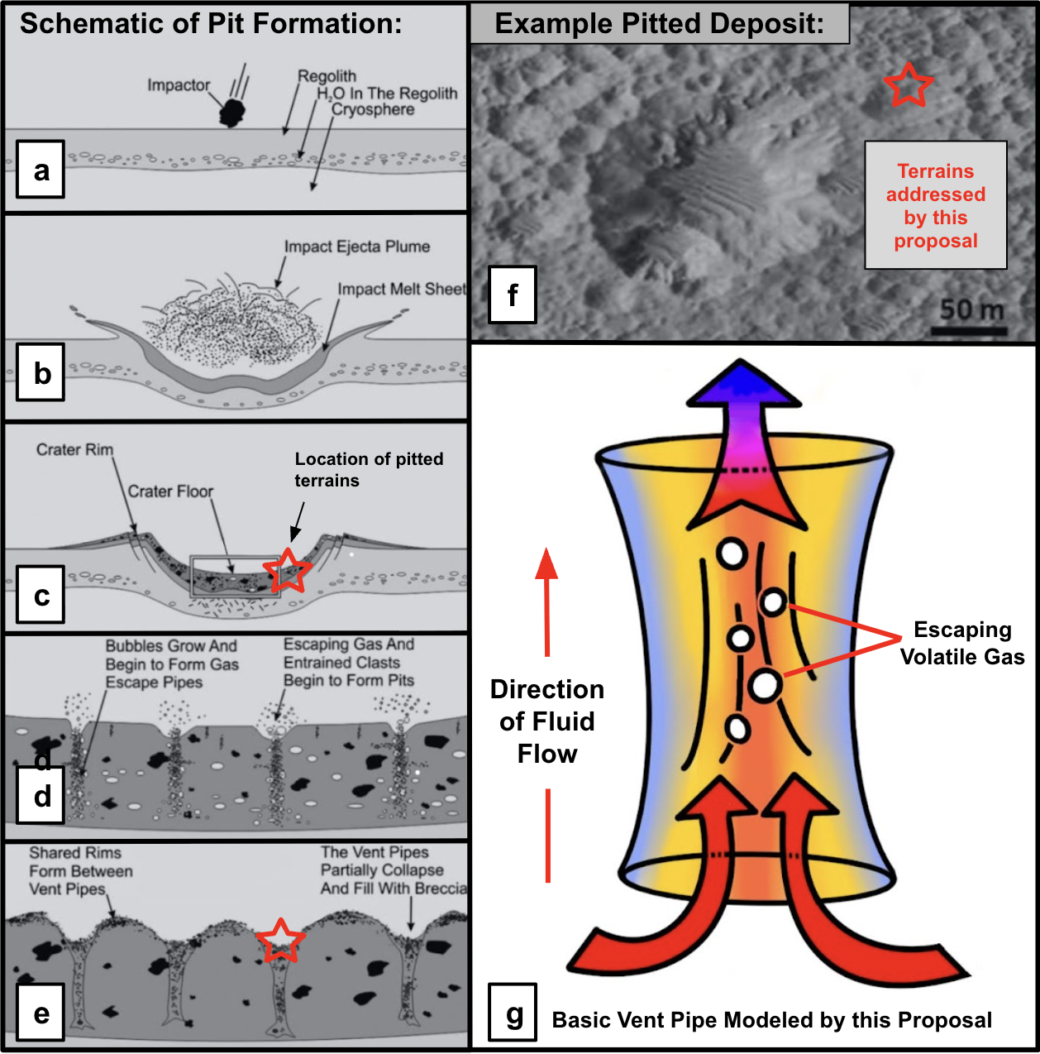

Caption: Constraining the dynamics of heat flow within Martian impact-generated hydrothermal systems is crucial to assessing the microbial habitability of these terrains. Panels a though f, modified from Boyce et al., 2012, describe the formation of vent pipes within impact melt deposits (impact into target material, followed by the formation of a melt sheet, volatile degassing, and formation of steam escape pipes with pitted terrains in between). Panel f is a portion of HiRISE image PSP_007406_2035 depicting varying sizes of pitted terrains on the floor of Tooting Crater on Mars, with red stars denoting areas where pitted terrains can be observed. Panel g is a schematic illustration of an isolated vent pipe structure, to be modeled by this proposal, with arrows indicating the direction of flow through the conduit. Our understanding of the dynamics of these systems is incomplete, given vent pipe structures within impact craters, and the pitted terrains they produce, have not been studied with modern finite element modeling approaches. We propose to model volatile escape through vent pipe structures using the finite element modeling software COMSOL Multiphysics, which will constrain the dynamics of fluid flow following impact events on the Martian surface. With these models, we will ascertain the duration of post-impact habitable temperatures and water volumes, informing future mission directions and sampling strategies which prioritize astrobiologically relevant terrains.

Section 4: Importance and Broader Implications

a) Create a heading that states the broader impact/importance of the solution.

Broader Impacts: Assessing Habitability as a NASA Priority

b) What is the high level importance of the proposed products of your study to your subfield? How will your study advance the subfield? (this is a like a summary statement)

- constraining habitability of impact-generated hydrothermal systems will permit deeper
astrobiological investigation, along with improved sampling site selection strategy

c) Repeat Suitability:

i) Why now?

- Decadal survey priority (Origins, Worlds, and Life → habitability)
- Worth mentioning rover technology, or MSR? May be too tenuous in terms of connection.

ii) How does this program relate to the funding call?
Which key science goals of HST/JWST does your proposal connect to ?
o JWST: https://webb.nasa.gov/content/science/index.html
o HST: https://www.stsci.edu/hst/about/key-science-themes
[ if applicable -> Observational] Repeat Why this facility?

- Not an HST/JWST proposal → science goals are within Decadal Survey
- Specific goals of funding call, quote language from funding call (?)

d) How does this study increase the legacy value of the facility/agency?
- What other subfields are advanced by these observations (GO) or data analysis/code/simulations (AR) ? [ Broader Impact]
And/OR
- Do the products of your proposal serve the community at large?

- This modeling program furthers NASA priorities of assessing the habitability of the Martian
surface and provides a blueprint for the assessment of impact-generated hydrothermal system
habitability in multiple craters across the Martian surface
- Other subfields: insights into the Martian crustal volatile content, with implications for
climate/paleoclimate modeling, as well as deeper understanding of physical impact processing
on Mars

